**Excell**

//sum =SUM(just click row and coma)enter 🡺

//mult =A1*B1*C1*D1

//Cell reference

=SUM(A2:D2)

//Fixed column $=fixed data

=($B$1*A2)

//Fixed to relative

=(B$1*$A2)

//select full row or colum

Cltr+ Shift + ><^v

//short key

alt

//random number

=RAND()

//date

=TODAY()

//date and time

=NOW()

//random Between

=RANDBETWEEN(4,10)

//random number function off

Cltr+c+v(paste(1,2,3))

//if

=IF(G2>15,"yes","no")

=IFERROR(IF(G2<40,"cold",IF(G2>80,"Hot","mild")),"other")

//fill full colum

Just click 2 time

//if null or missing value find

=IFERROR(IF(G2>15,"yes","no"),"other")

//NOT

=IF(NOT(C2=0),“Wet","Dry")

=IF(C2<>0,"Wet","Dry")

//AND

=IF(OR(F2="Rain",F2="Snow"), "Wet","Dry")

//OR

=IF(AND(D2="Yes",C2>0),"Snow",IF(AND(D2="No",C2>0),"Rain","None"))

//Statistic finction

=COUNT(A2:A20)

=AVERAGE(A2:A20)

=MEDIAN(A2:A20)

=MODE(A2:A20)

=MAX(A2:A20)

=MIN(A2:A20)

=PERCENTILE(A2:A20,.25)

=PERCENTILE(A2:A20,75) ESTDEV(A2:A20)

=VAR(A2:A20)

//Rank

=RANK(L8,L6:L17,0)

//LARGE

=LARGE(10,1)

//small

=small(10,1)

//sumproduct

SUMPRODUCT((A2:A17="Shaws")*(B2:B17="Apple")*C2:C17*D2: D17)

//2 table data find

=VLOOKUP($A2,$J$5:$L$9,3,0)//3=price table

//2 table data find horizontal

=HLOOKUP(A4,$J$6:$M$8,2,0)

//space remover

=TRIM(D13)

//Lower case sentence

=LOWER(D13)

//upper case upper case sentence

=UPPER(D13)

//proper case for proper sentence

=PROPER(D13)

//transpose

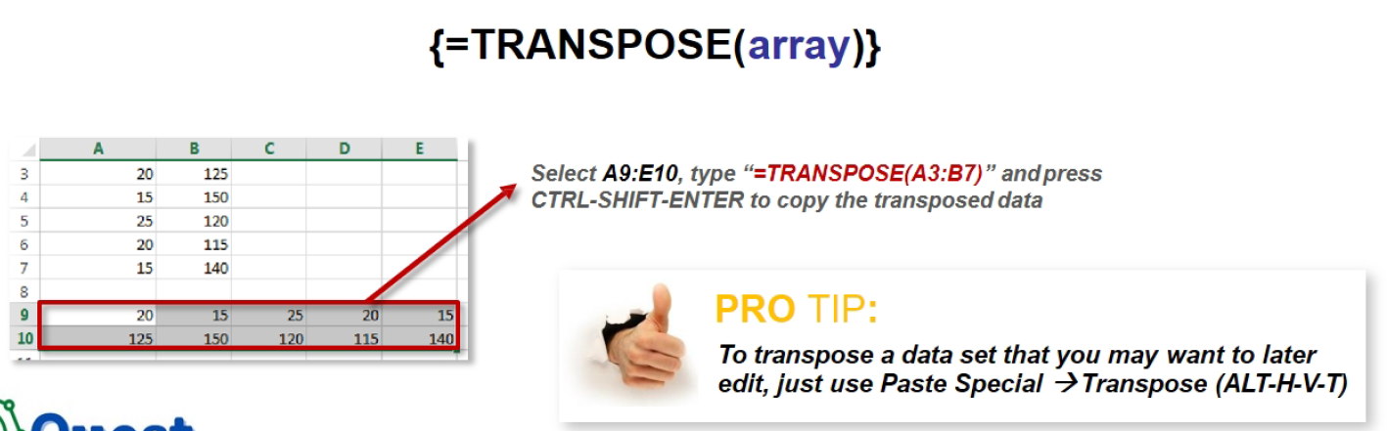

//Concatenate

=CONCATENATE(A2,"",B2)

//hyper link

=HYPERLINK("https://www.facebook.com","facebook")

//left right mid len

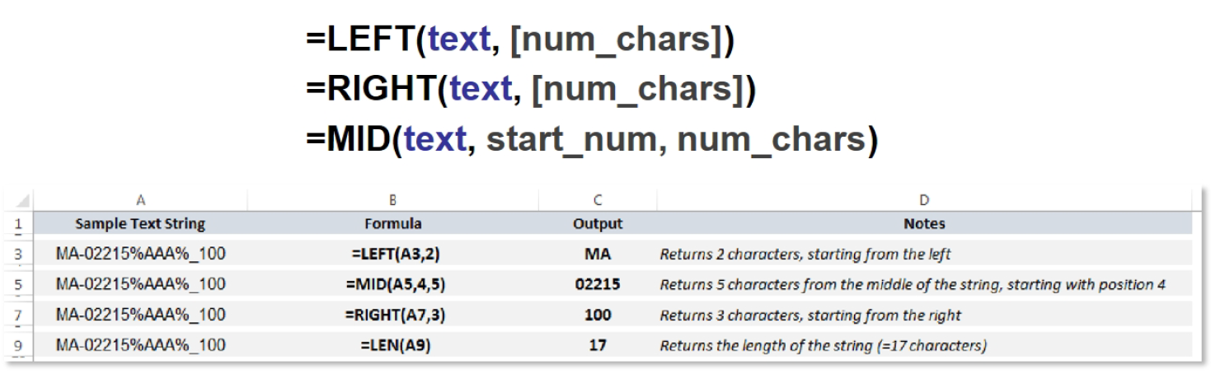

//COUNTIF

=COUNTIFS($A:$A,"2010")

=COUNTIFS($A:$A,$J$3,$C:$C,$K$3)

//SUMIFS

=SUMIFS($E:$E,$A:$A,$J$3,$C:$C,$K$3)

=SUMIFS($E:$E,$A:$A,"2010",$C:$C,"NL")

//data validation

//search or filter data

For search: =team_name!$A$2:$A$33

//search any data

=LEFT(l2,SEARCH(“@”,l2)-1)

//missing value hendal

1st calculate median just write =MEDIAN(1atdata:latsdata)

=IF(table_row=””,$median,table_row)

//cut and back

Cltr +z

//cut back

Cltr+shift+z

PIVOTE TABLE

//add row click change data source

// add slicer to change data button

//connect slicer all to use option->report connection